1. 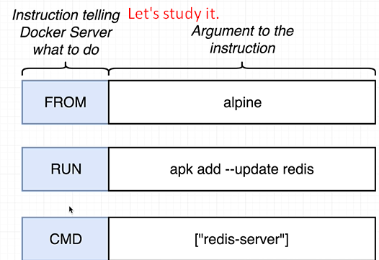
2. Let’s have some analogy to understand purpose of those configuration lines in docker file 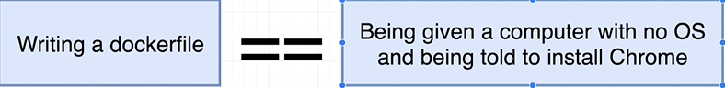.
3. Here is probably you would end up doing.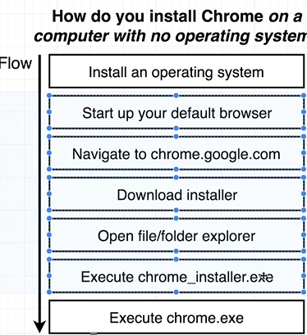
4. **  
   FROM alpine** 🡸 First Configuration line in Docker file.
   1. So these steps right here very similar to what we just did inside that Docker file when we specify that base image of Alpine that was a lot like installing an initial OS. By default when we create image we have an empty image. There is really nothing inside there no infrastructure, no program so we can use to navigate around a file or folder system. There is nothing we can use to download or install or configure dependencies.   
      The purpose of specifying a base image is to kind of give us an initial starting point or initial set of programs that we can use to further customize our image.
5. 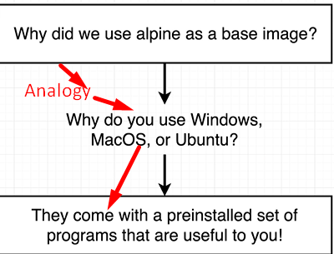  
   Alpine comes with pre-installed programs useful to install and running redis.
6.   
   This line (“apk add”) has nothing do to with docker.  
   APK is apache Package which is package manager that is pre-installed on Alpine image. This package manager can be used to download and install redis.
7. Let’s understand the following in the next chapter.  
   